Name: Nam Jun Lee

WSU ID: 011606459

Assignment: Assignment #5

Class number: 2021 Fall-MIS-325-ONLIN-2217-H72-01-10356-LEC

Date: November 19th , 2021

<https://cb-ot-devst06.ad.wsu.edu/MF13namjun.lee/Assignment5/Assignment5.aspx>

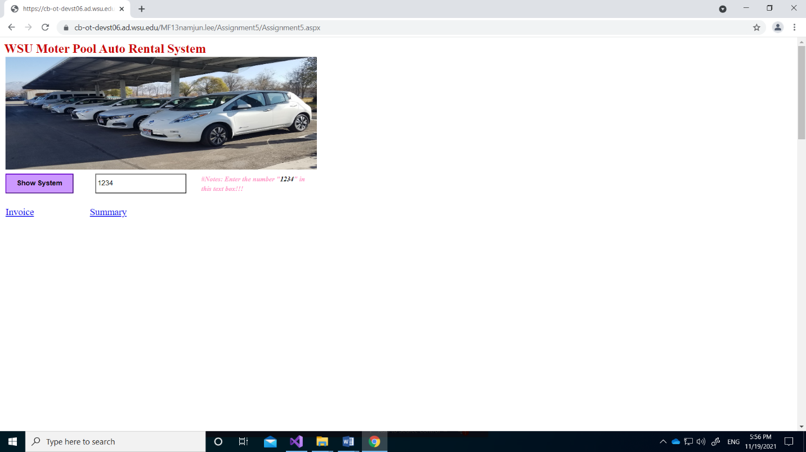

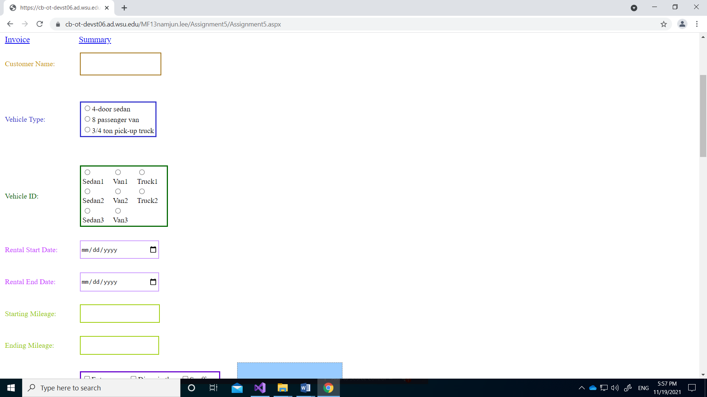

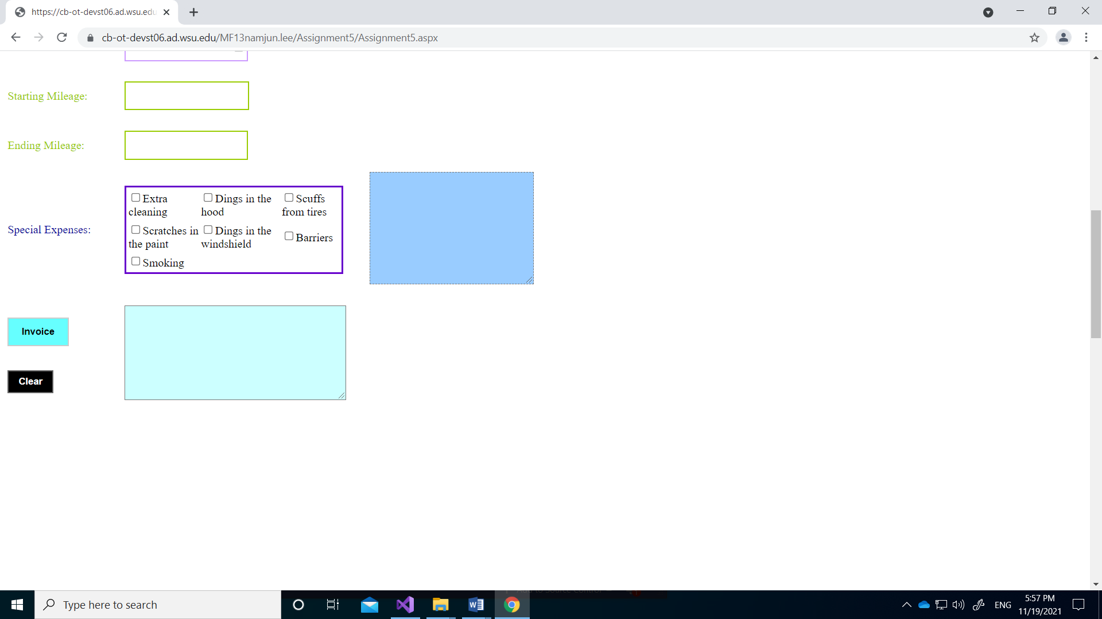

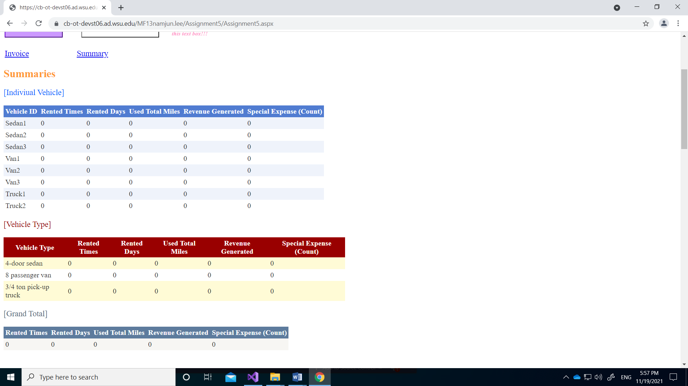

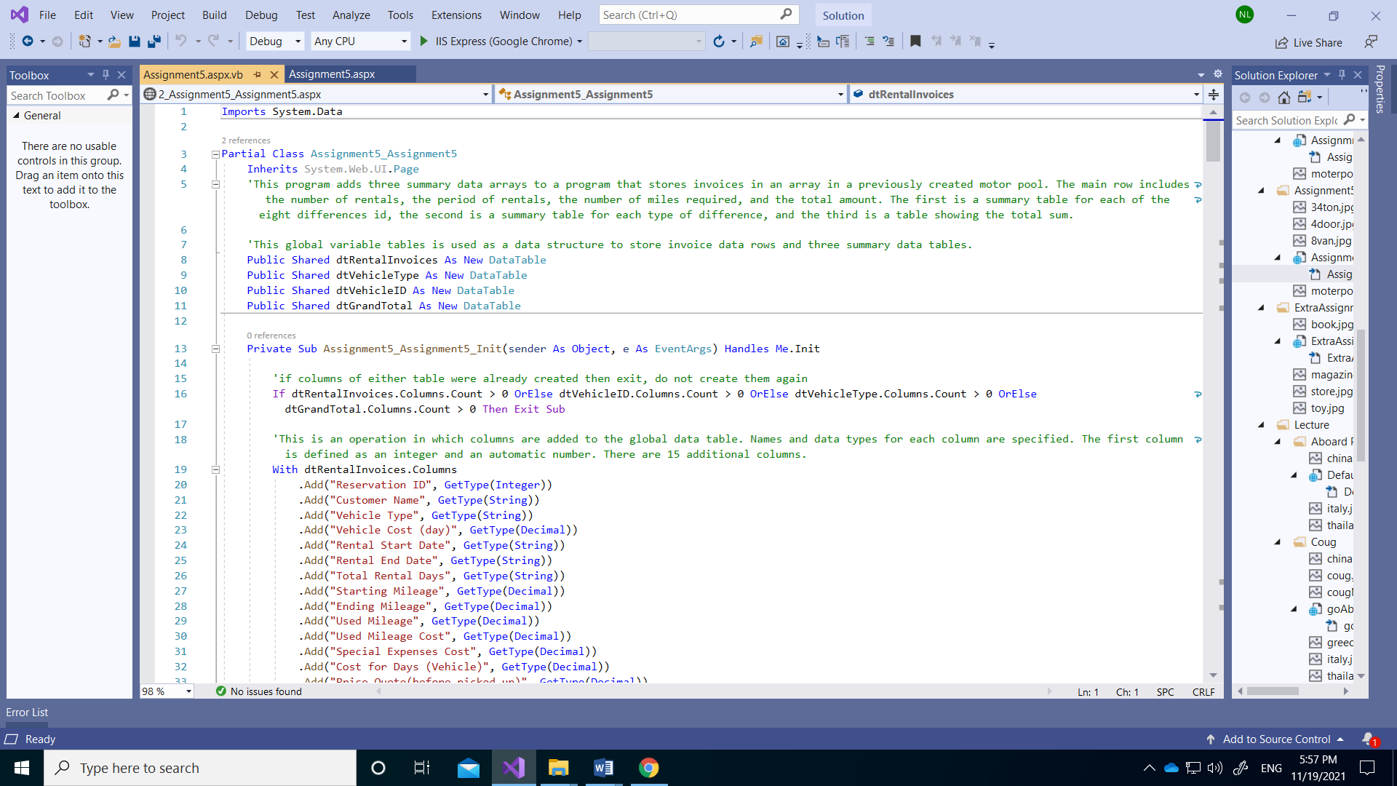

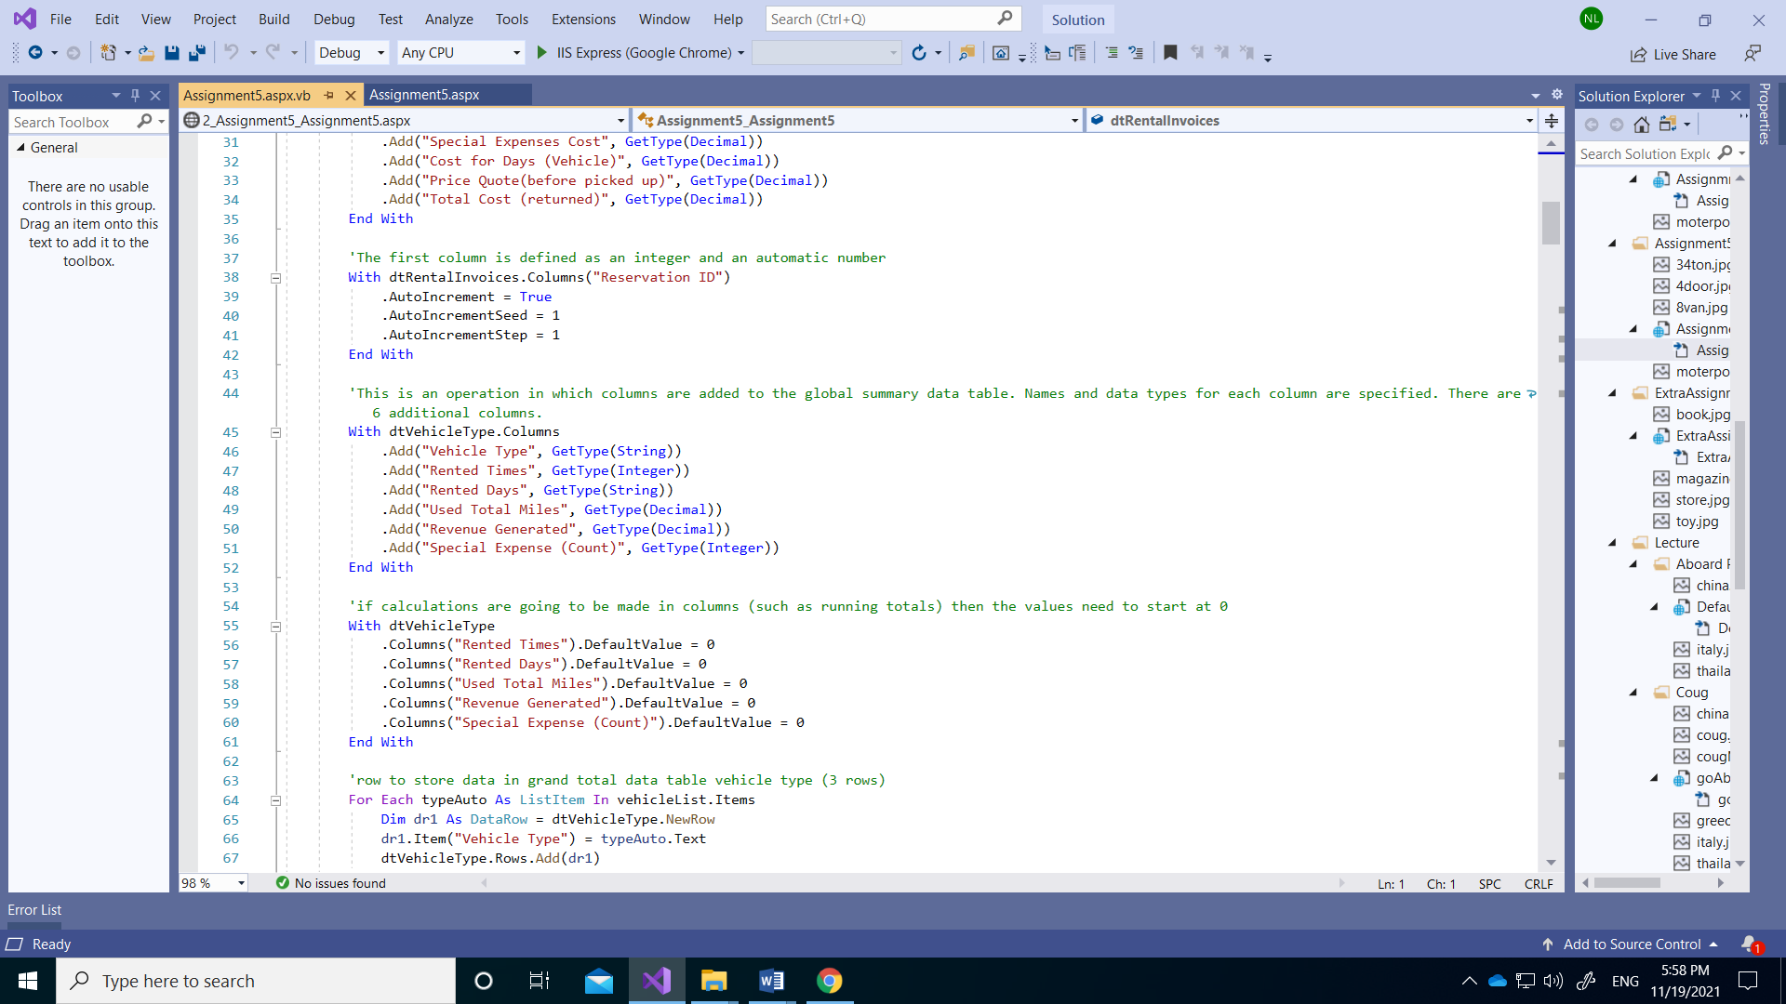

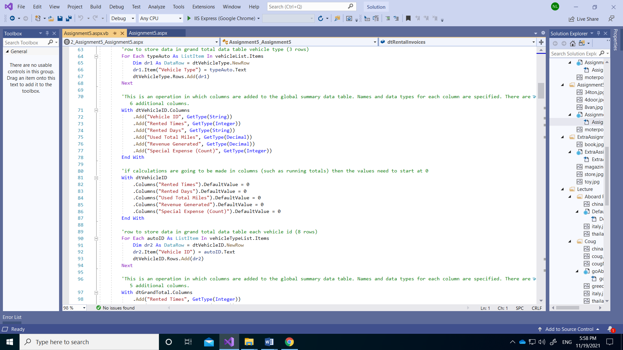

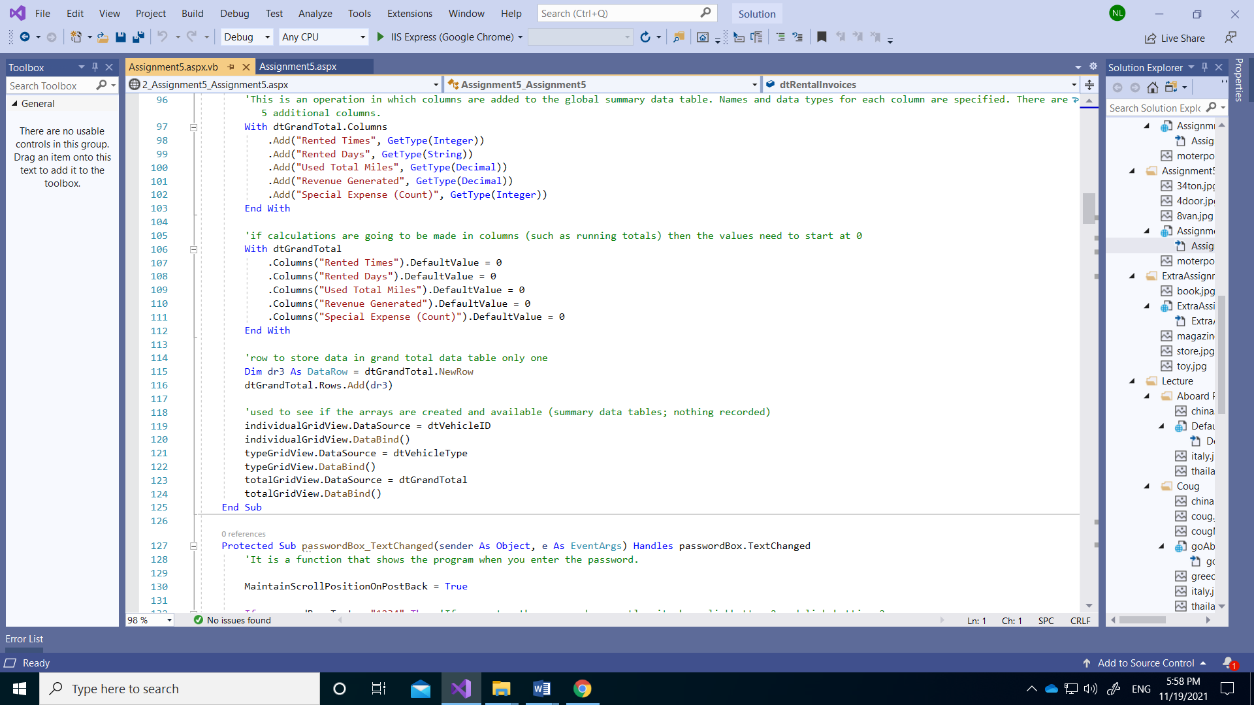

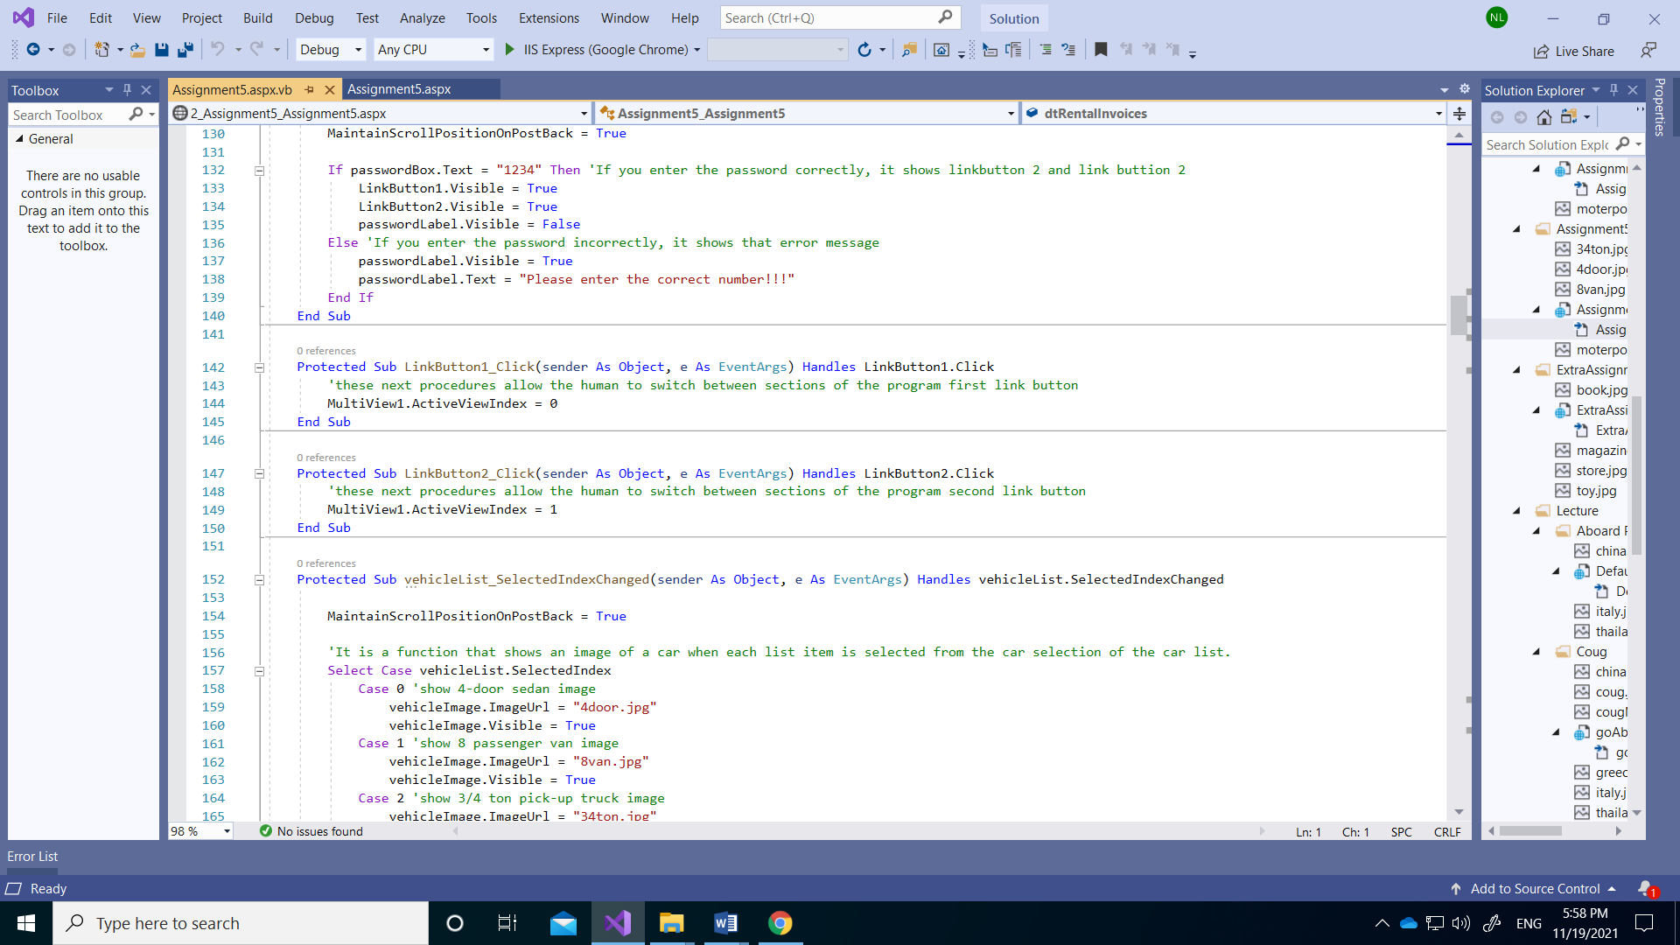

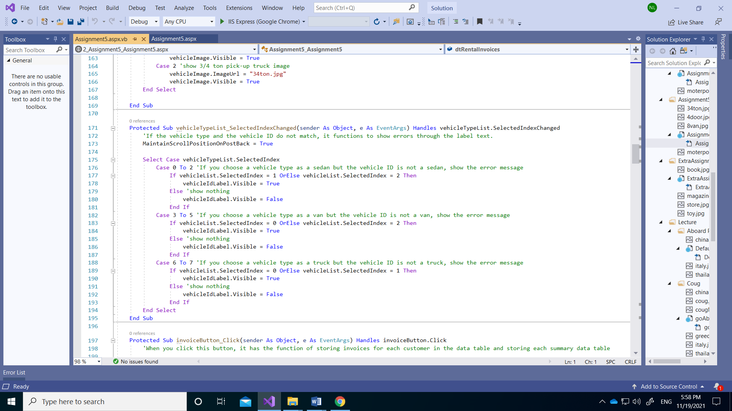

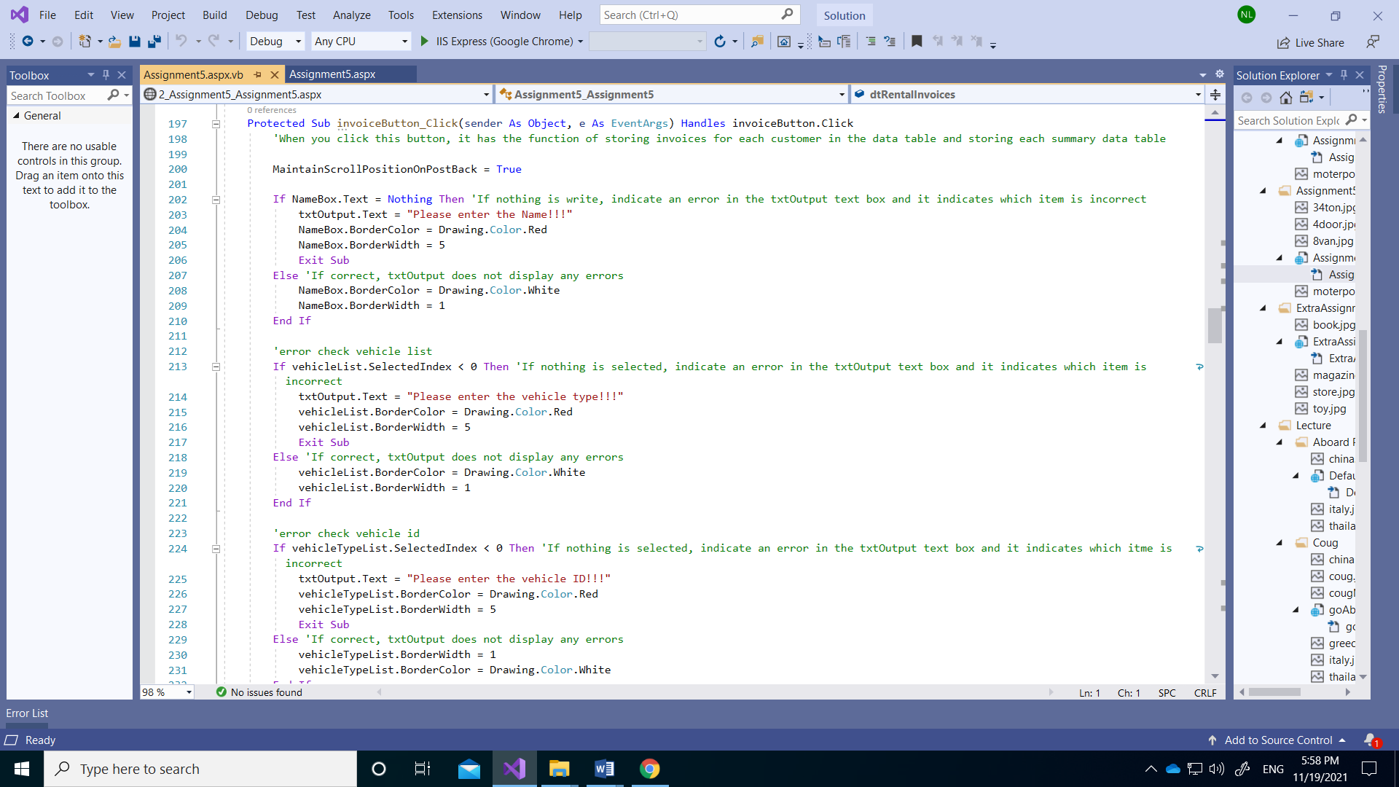

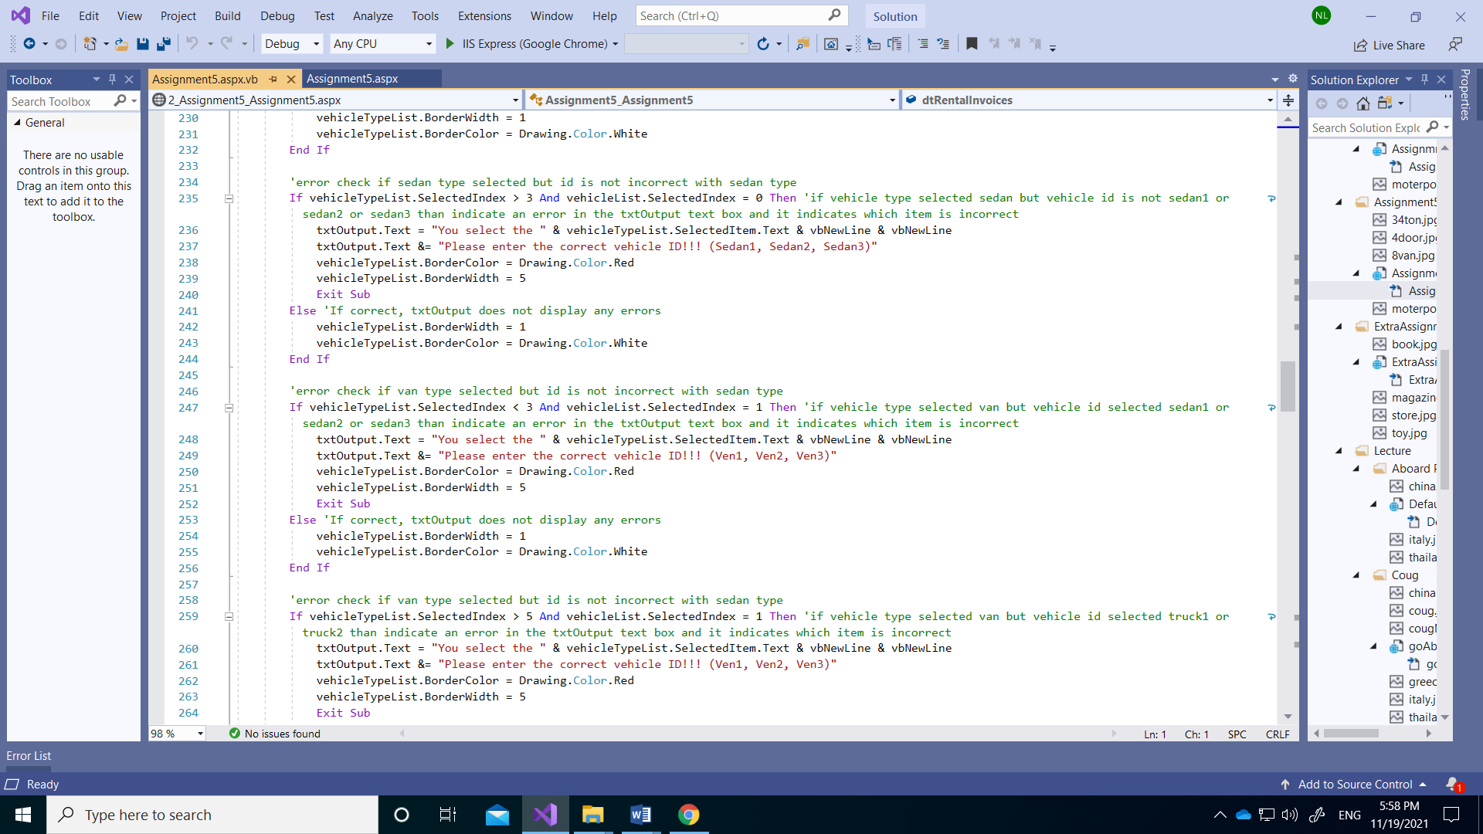

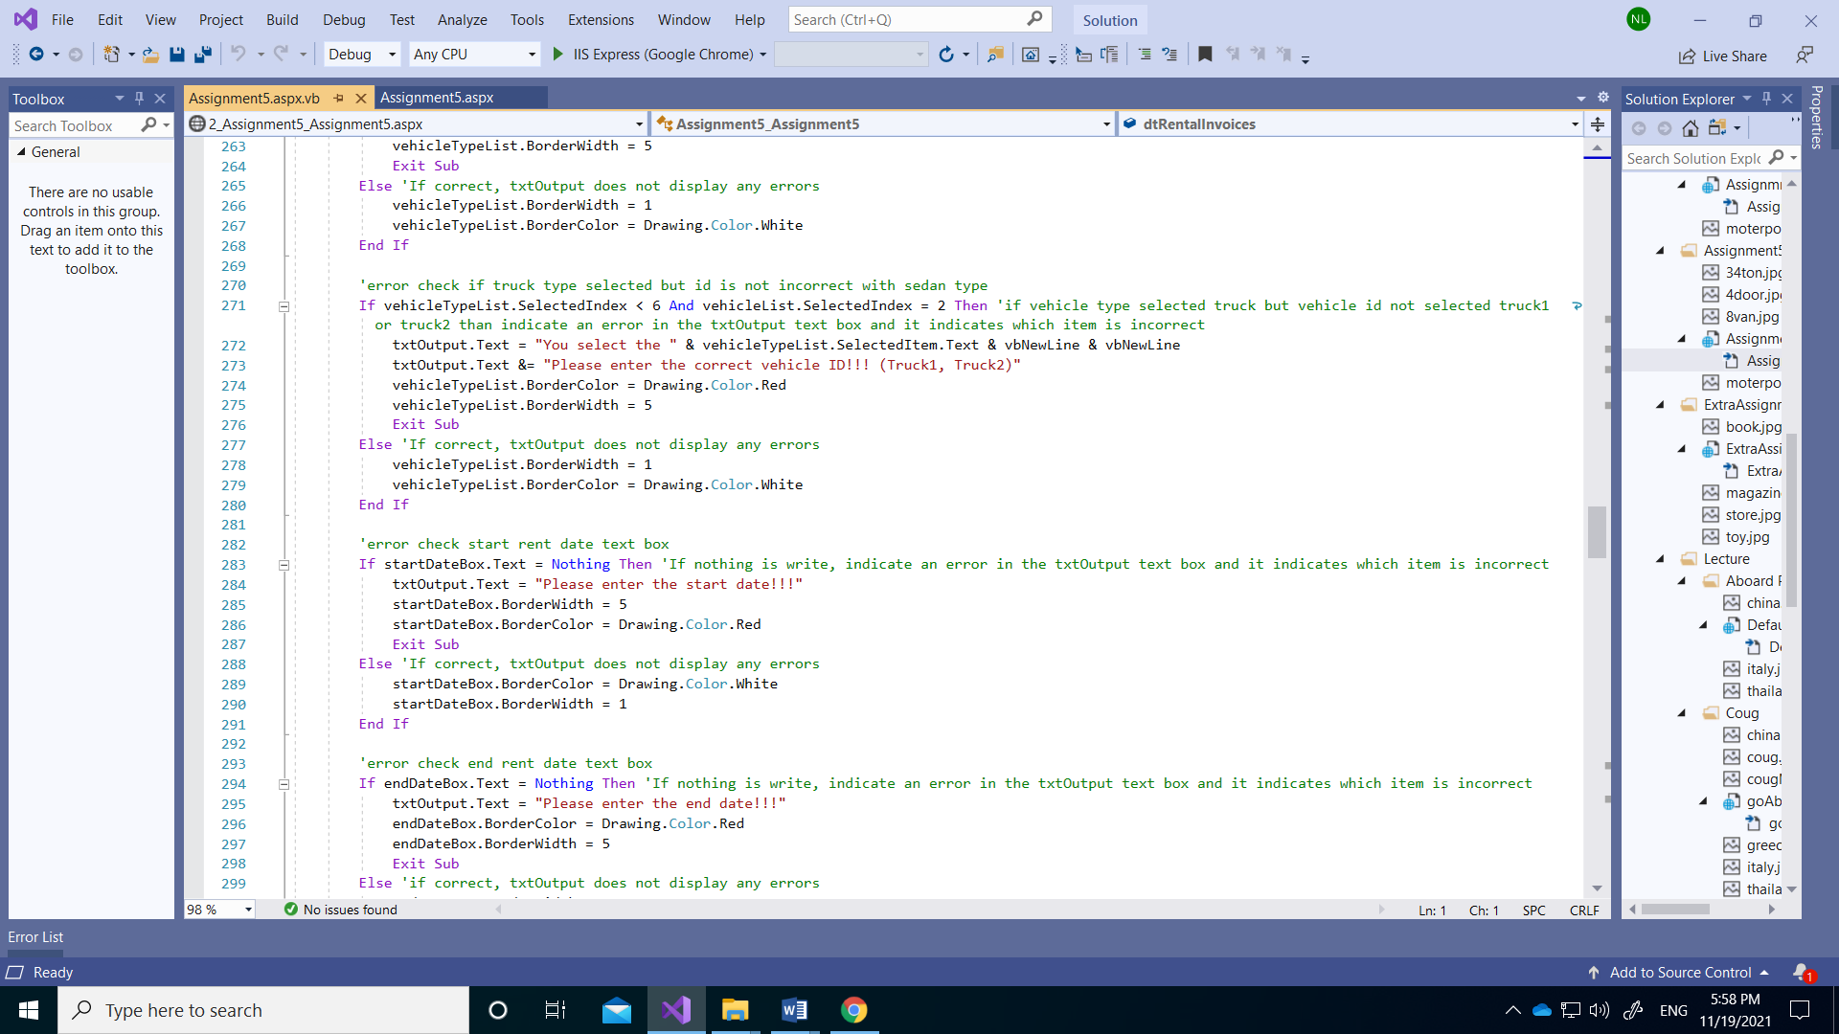

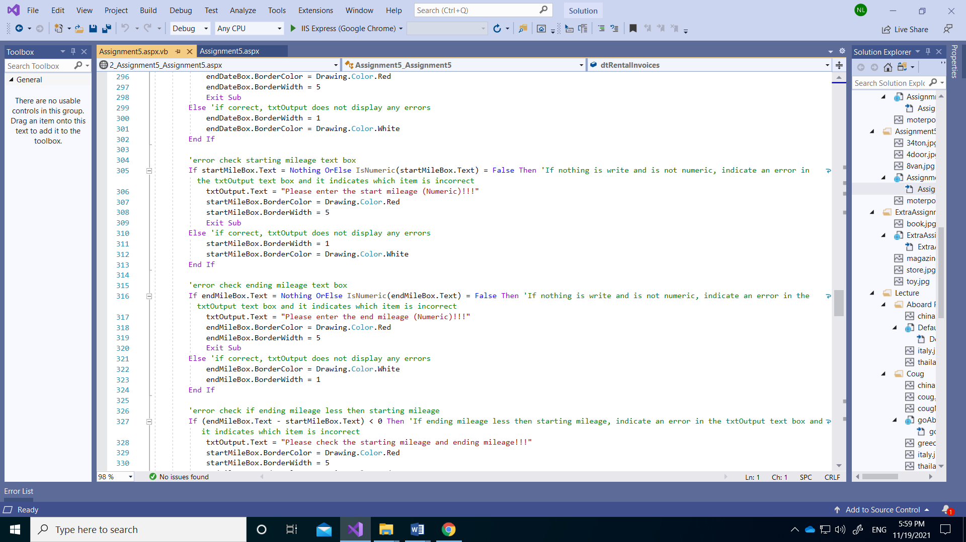

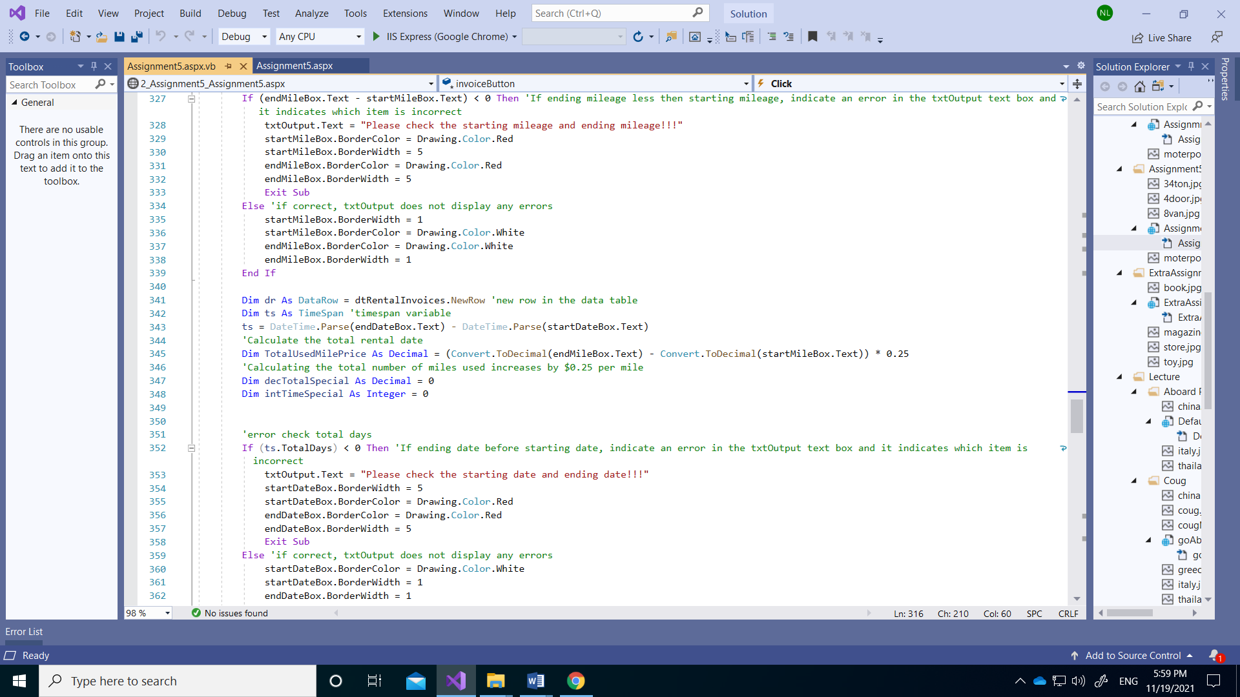

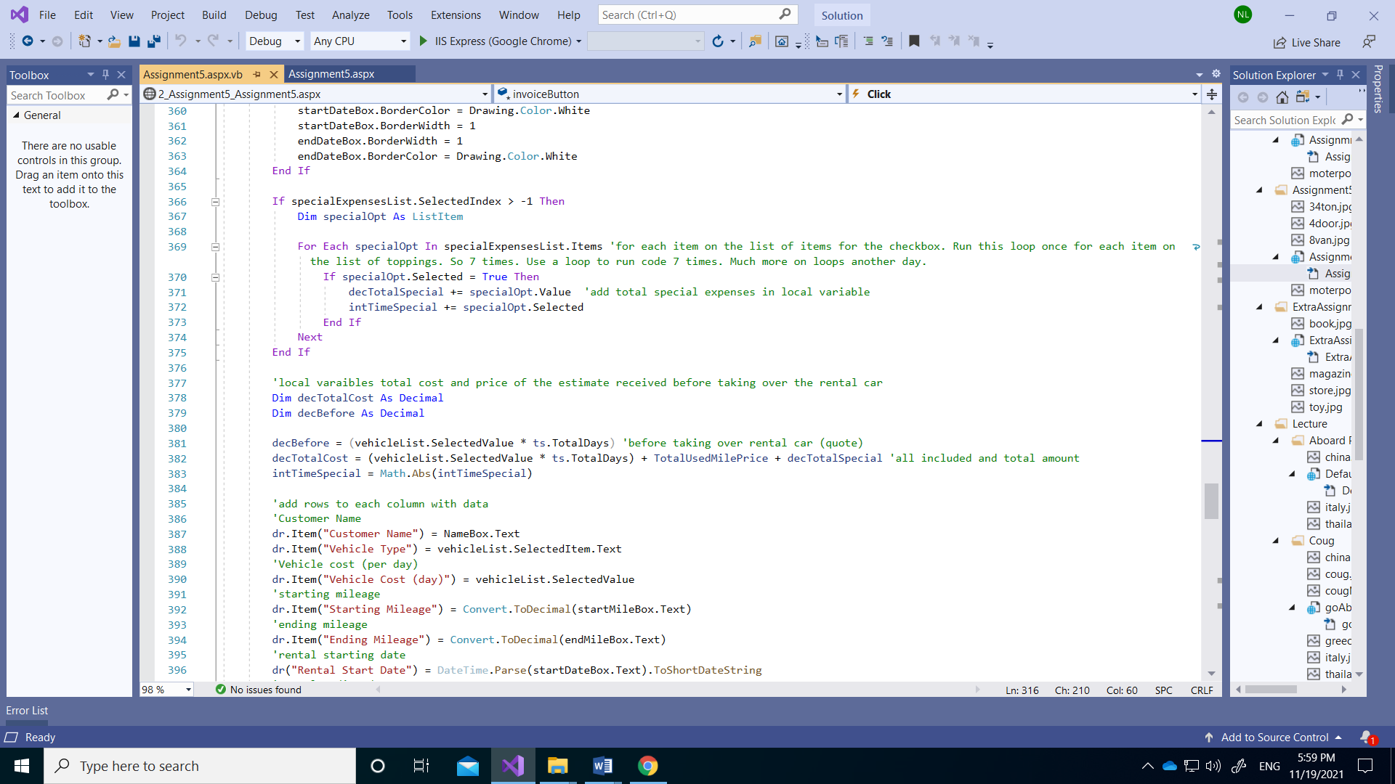

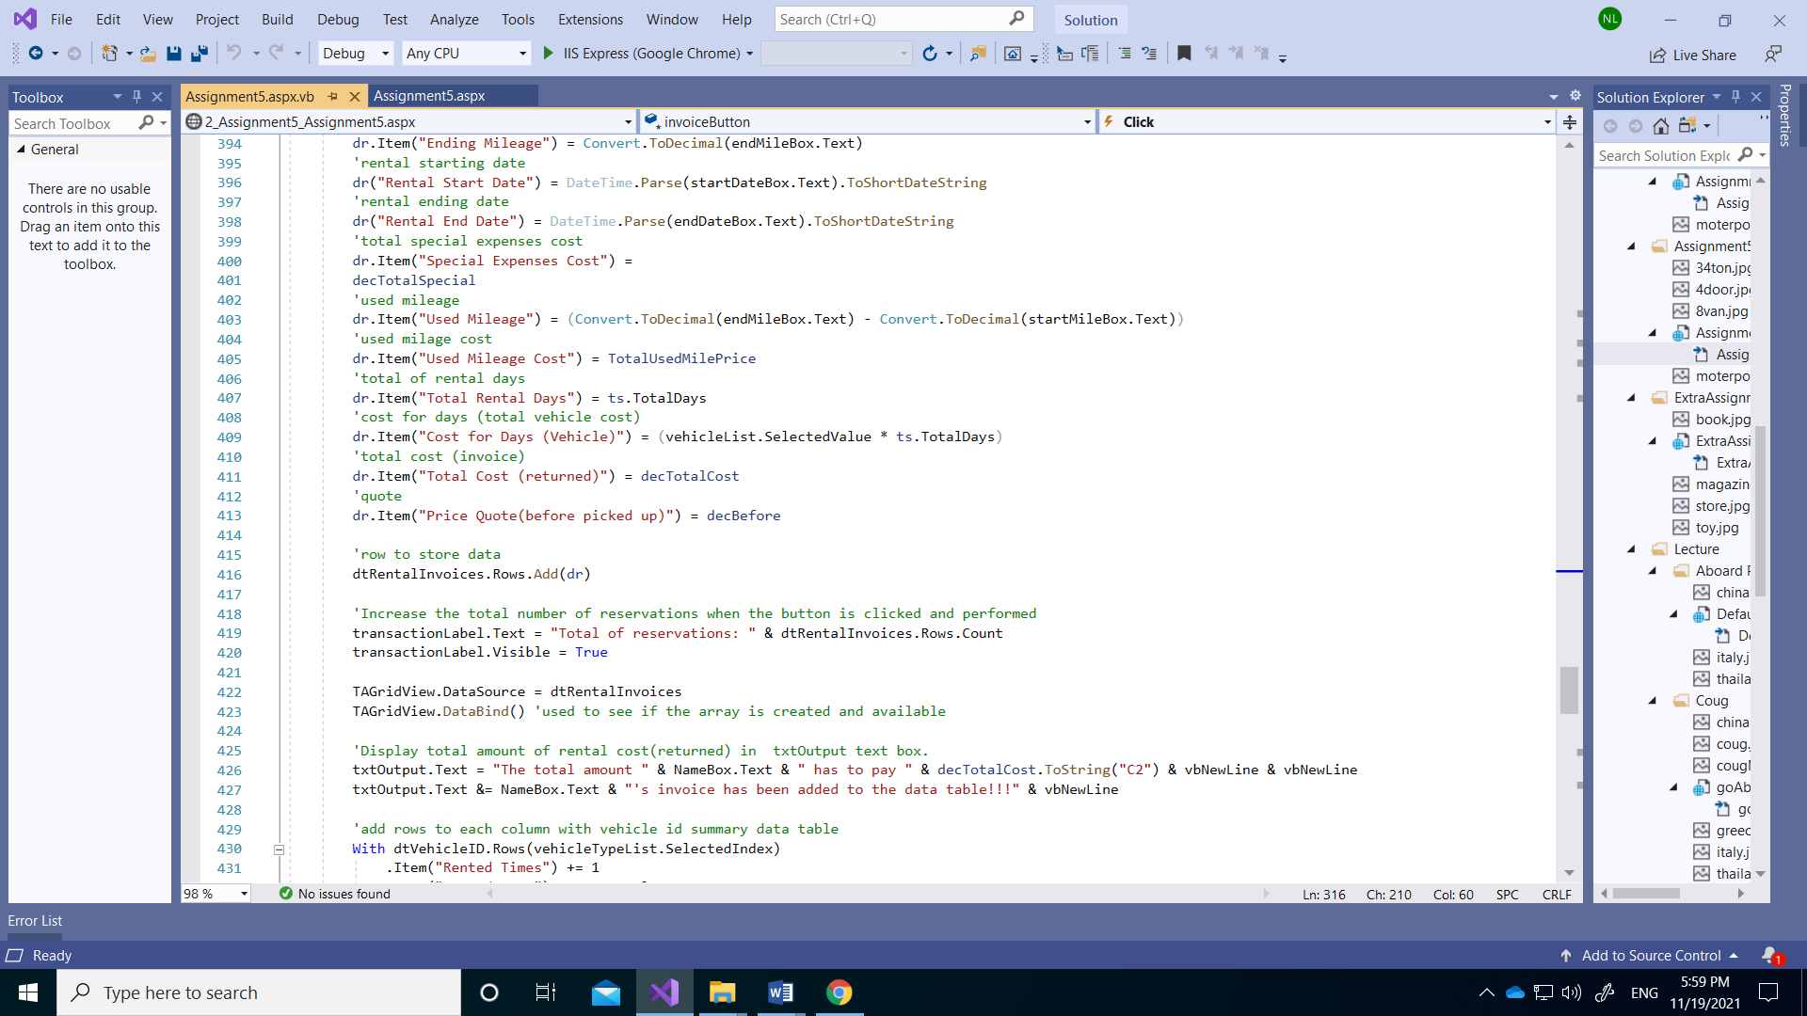

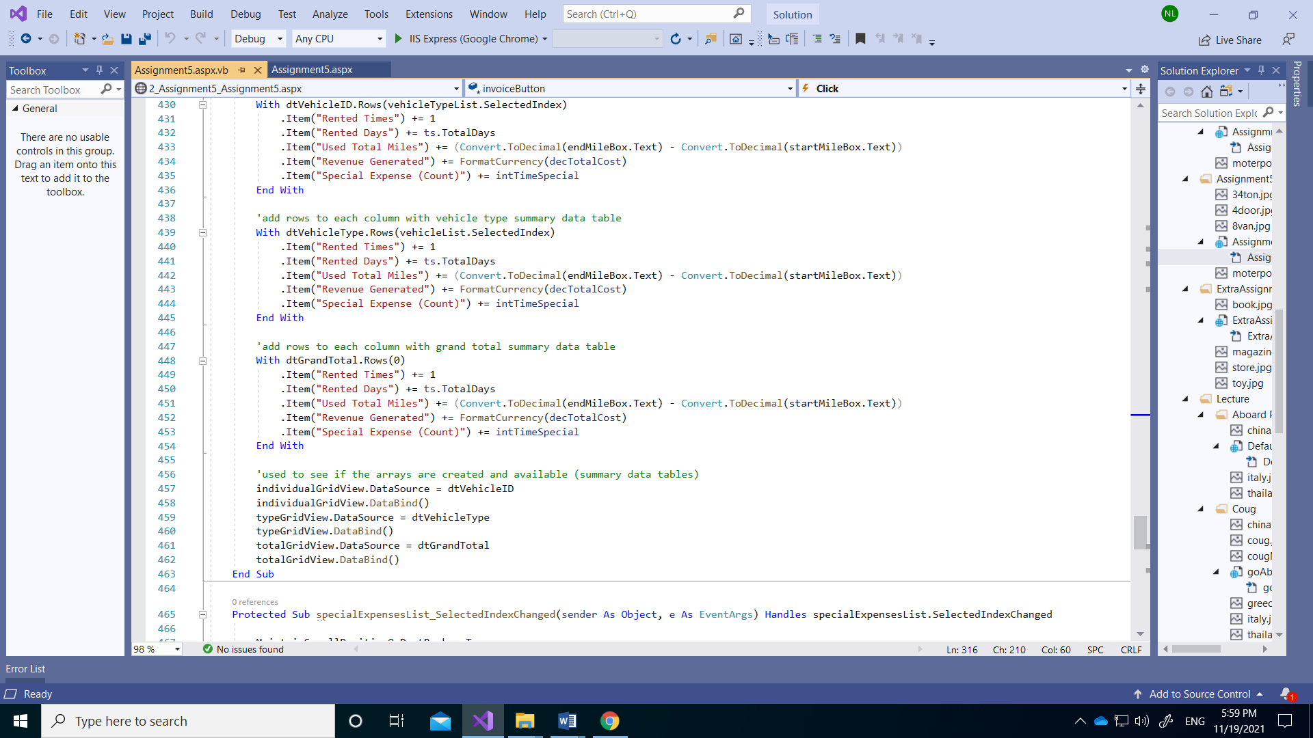

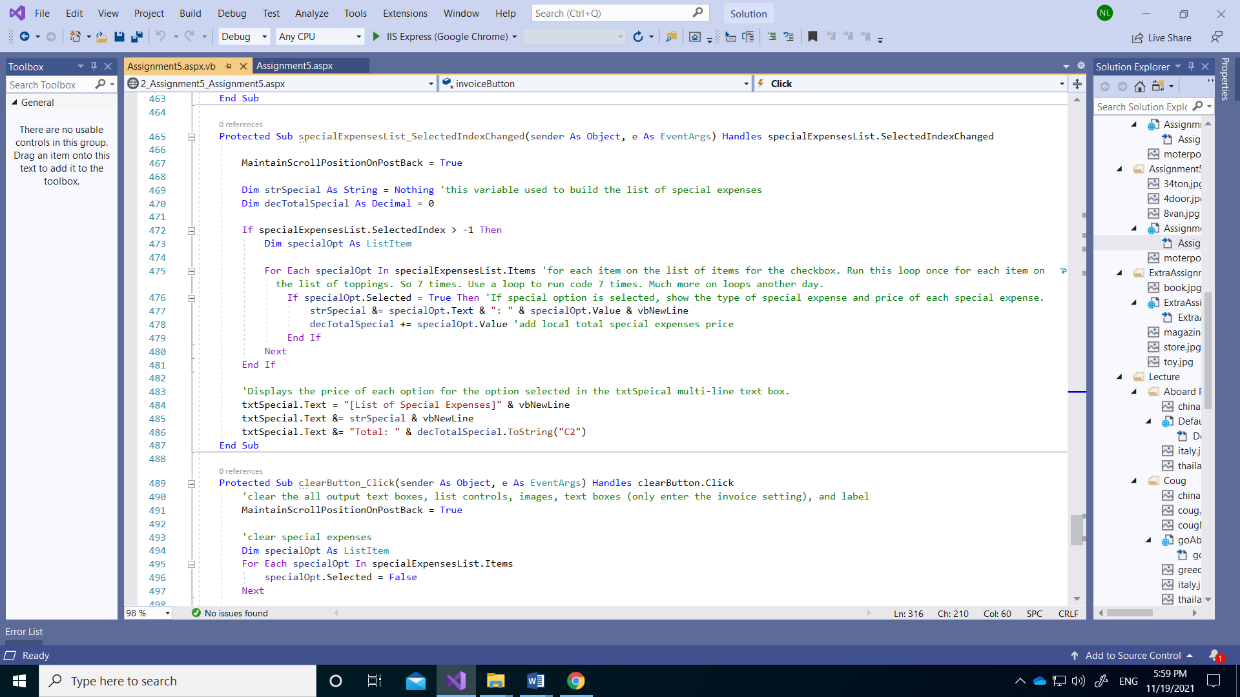

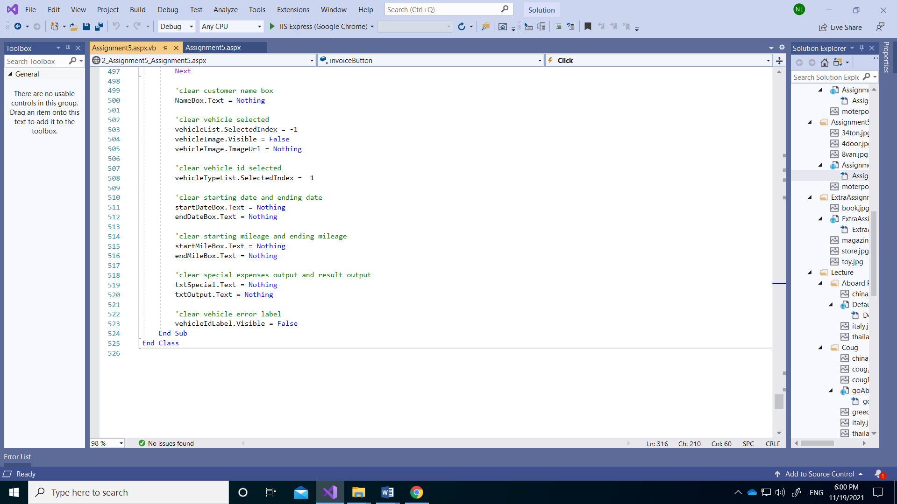

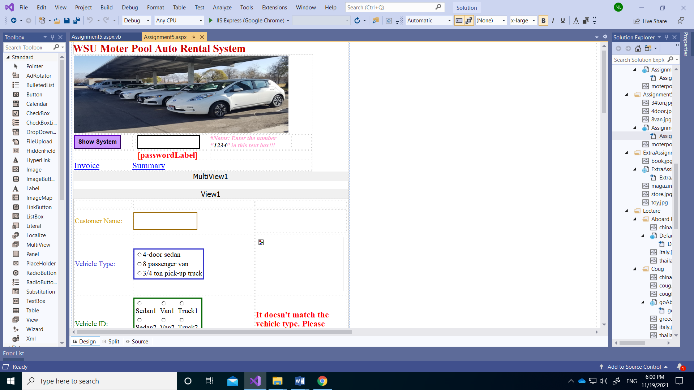

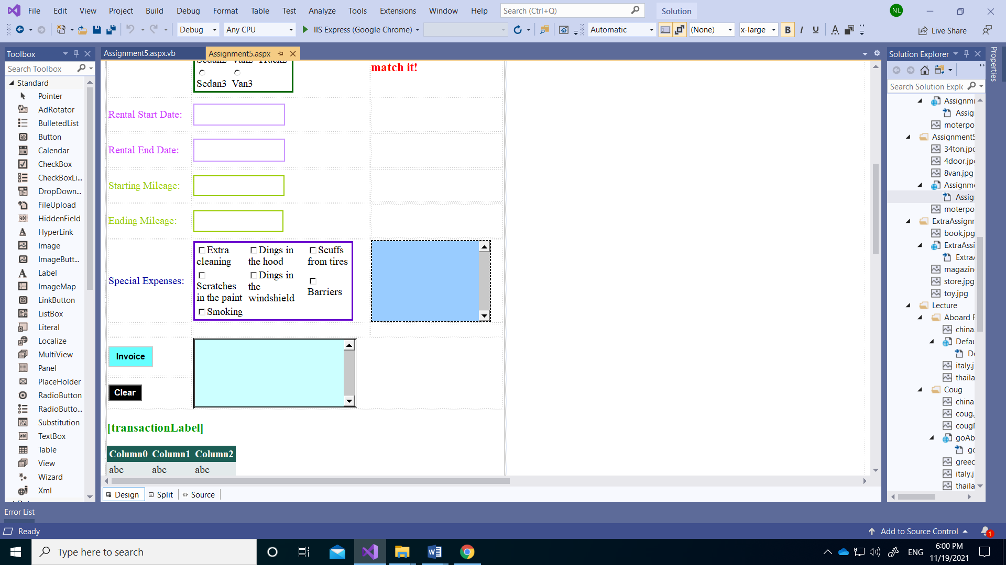

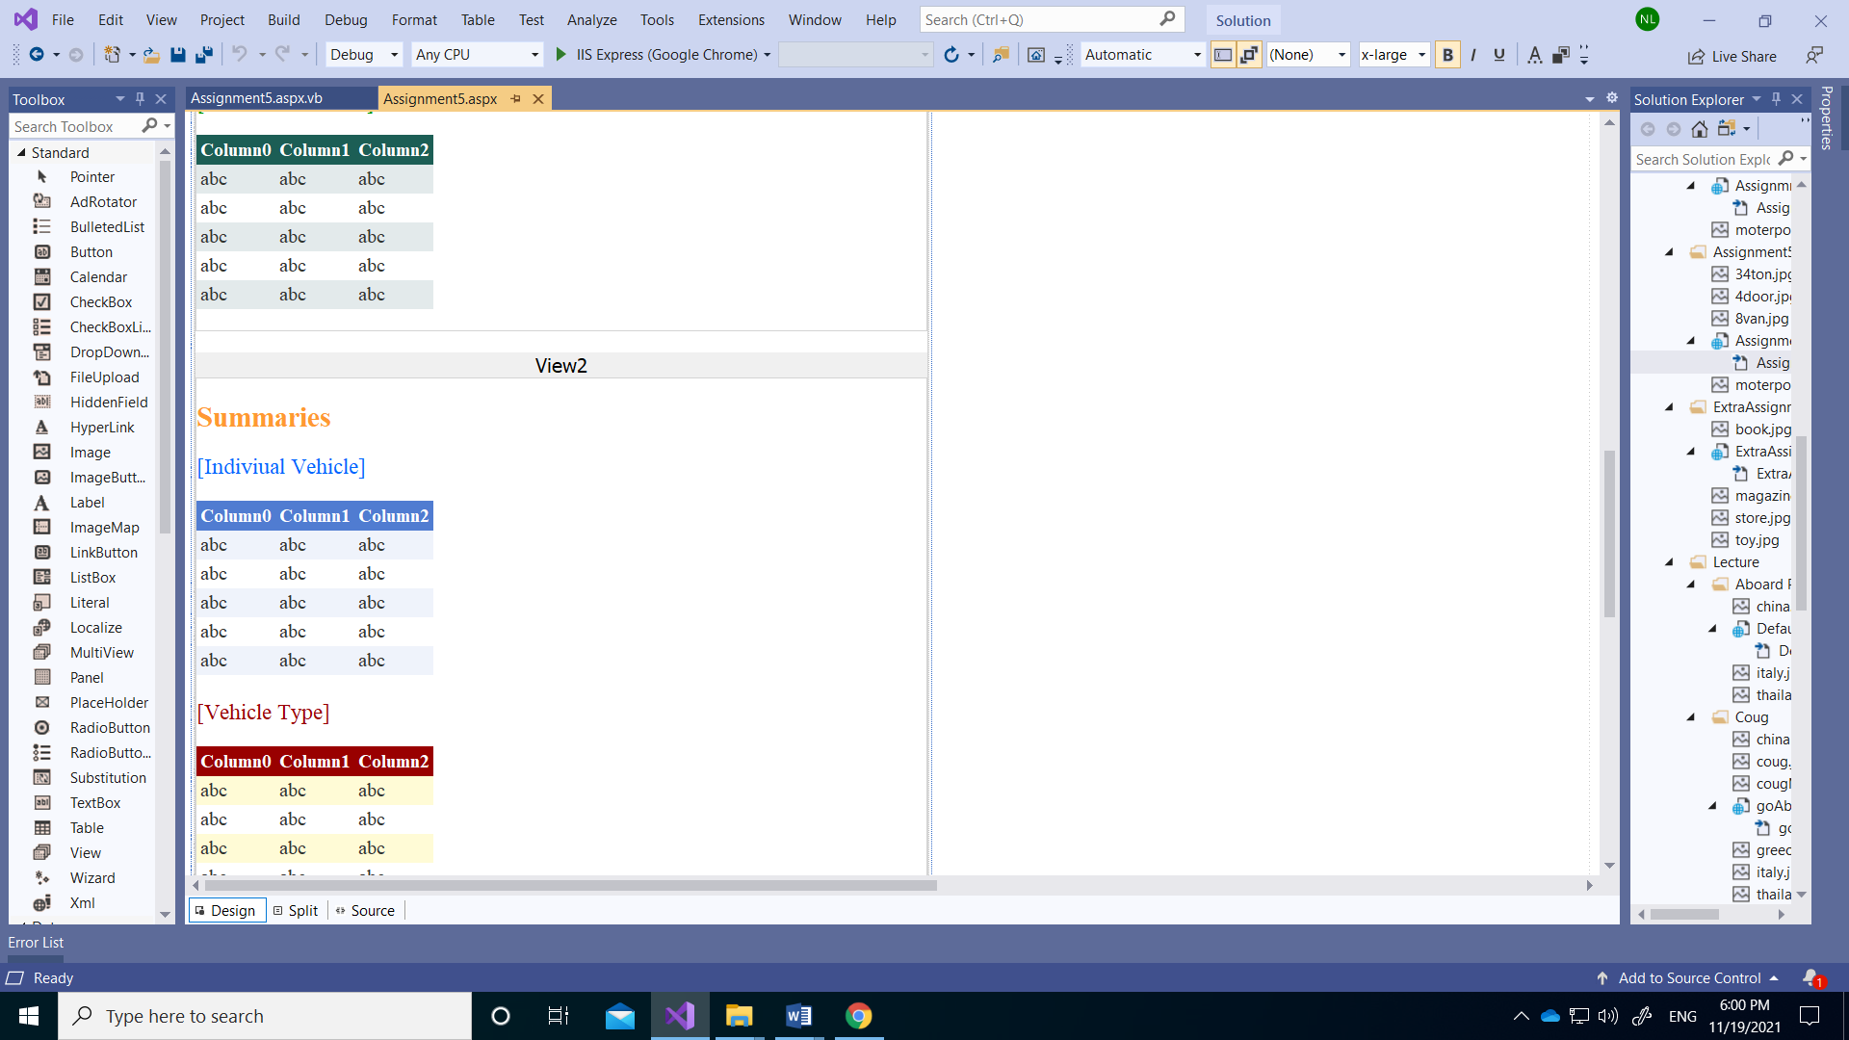

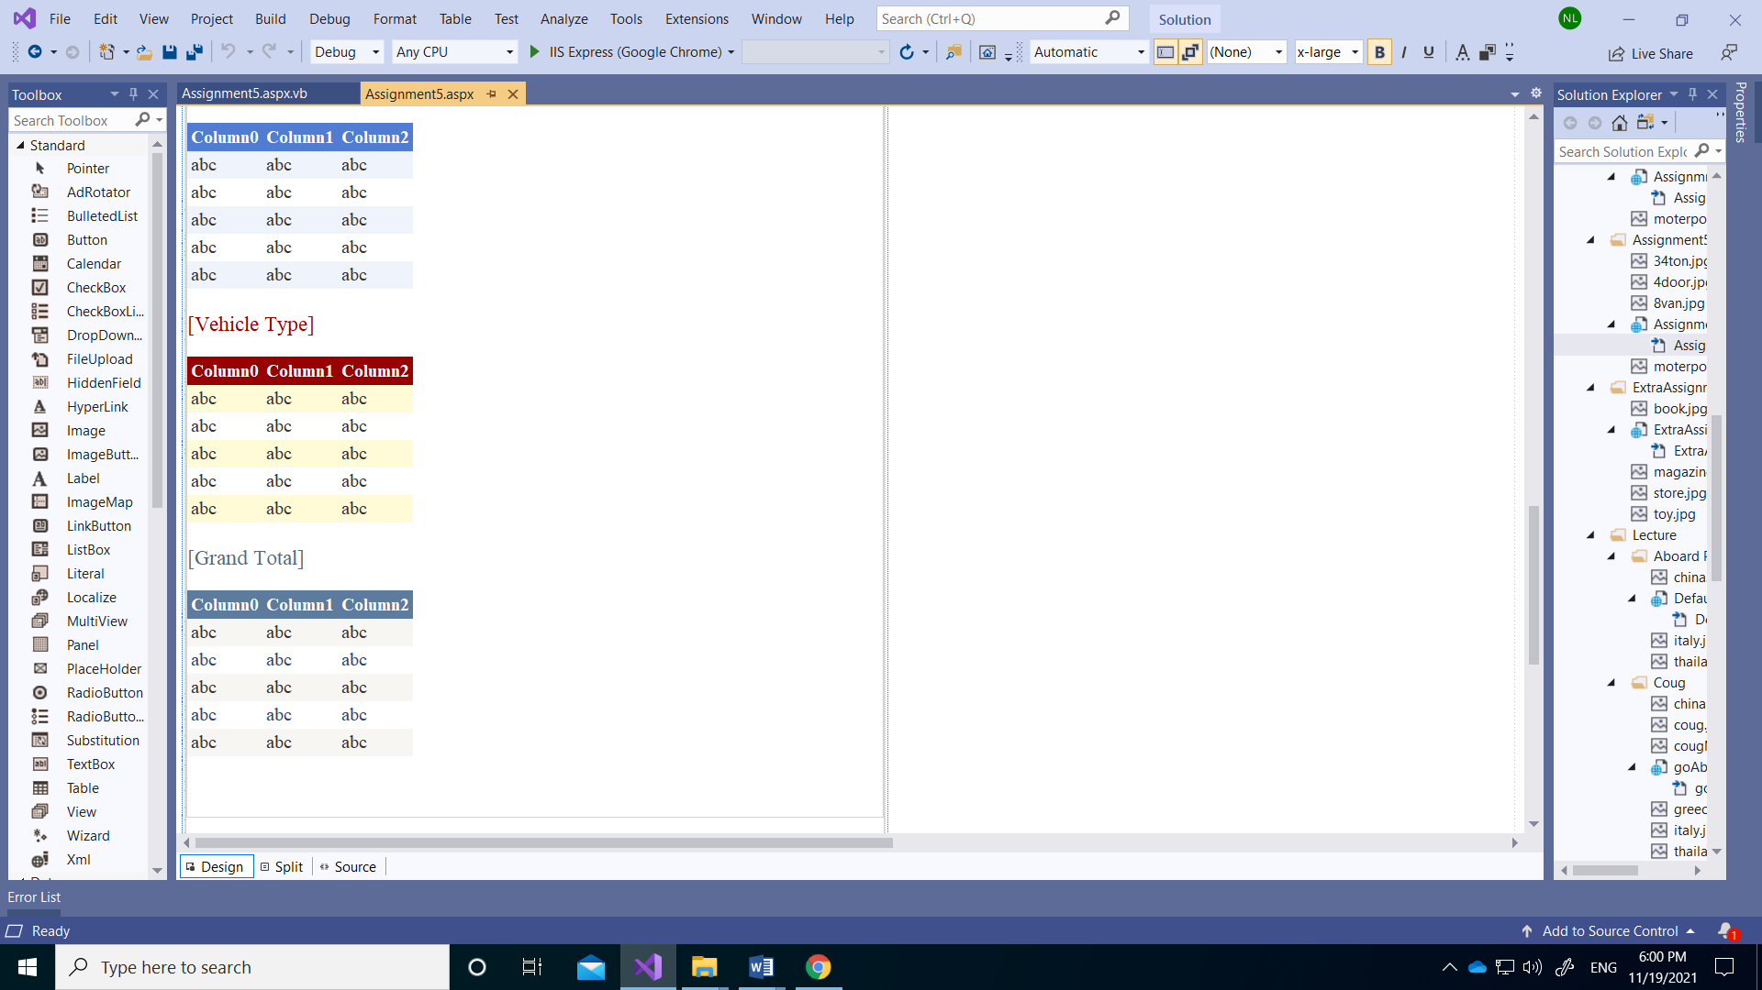

**Aspx.vb code:**

Imports System.Data

Partial Class Assignment5_Assignment5

Inherits System.Web.UI.Page

'This program adds three summary data arrays to a program that stores invoices in an array in a previously created motor pool. The main row includes the number of rentals, the period of rentals, the number of miles required, and the total amount. The first is a summary table for each of the eight differences id, the second is a summary table for each type of difference, and the third is a table showing the total sum.

'This global variable tables is used as a data structure to store invoice data rows and three summary data tables.

Public Shared dtRentalInvoices As New DataTable

Public Shared dtVehicleType As New DataTable

Public Shared dtVehicleID As New DataTable

Public Shared dtGrandTotal As New DataTable

Private Sub Assignment5_Assignment5_Init(sender As Object, e As EventArgs) Handles Me.Init

'if columns of either table were already created then exit, do not create them again

If dtRentalInvoices.Columns.Count > 0 OrElse dtVehicleID.Columns.Count > 0 OrElse dtVehicleType.Columns.Count > 0 OrElse dtGrandTotal.Columns.Count > 0 Then Exit Sub

'This is an operation in which columns are added to the global data table. Names and data types for each column are specified. The first column is defined as an integer and an automatic number. There are 15 additional columns.

With dtRentalInvoices.Columns

.Add("Reservation ID", GetType(Integer))

.Add("Customer Name", GetType(String))

.Add("Vehicle Type", GetType(String))

.Add("Vehicle Cost (day)", GetType(Decimal))

.Add("Rental Start Date", GetType(String))

.Add("Rental End Date", GetType(String))

.Add("Total Rental Days", GetType(String))

.Add("Starting Mileage", GetType(Decimal))

.Add("Ending Mileage", GetType(Decimal))

.Add("Used Mileage", GetType(Decimal))

.Add("Used Mileage Cost", GetType(Decimal))

.Add("Special Expenses Cost", GetType(Decimal))

.Add("Cost for Days (Vehicle)", GetType(Decimal))

.Add("Price Quote(before picked up)", GetType(Decimal))

.Add("Total Cost (returned)", GetType(Decimal))

End With

'The first column is defined as an integer and an automatic number

With dtRentalInvoices.Columns("Reservation ID")

.AutoIncrement = True

.AutoIncrementSeed = 1

.AutoIncrementStep = 1

End With

'This is an operation in which columns are added to the global summary data table. Names and data types for each column are specified. There are 6 additional columns.

With dtVehicleType.Columns

.Add("Vehicle Type", GetType(String))

.Add("Rented Times", GetType(Integer))

.Add("Rented Days", GetType(String))

.Add("Used Total Miles", GetType(Decimal))

.Add("Revenue Generated", GetType(Decimal))

.Add("Special Expense (Count)", GetType(Integer))

End With

'if calculations are going to be made in columns (such as running totals) then the values need to start at 0

With dtVehicleType

.Columns("Rented Times").DefaultValue = 0

.Columns("Rented Days").DefaultValue = 0

.Columns("Used Total Miles").DefaultValue = 0

.Columns("Revenue Generated").DefaultValue = 0

.Columns("Special Expense (Count)").DefaultValue = 0

End With

'row to store data in grand total data table vehicle type (3 rows)

For Each typeAuto As ListItem In vehicleList.Items

Dim dr1 As DataRow = dtVehicleType.NewRow

dr1.Item("Vehicle Type") = typeAuto.Text

dtVehicleType.Rows.Add(dr1)

Next

'This is an operation in which columns are added to the global summary data table. Names and data types for each column are specified. There are 6 additional columns.

With dtVehicleID.Columns

.Add("Vehicle ID", GetType(String))

.Add("Rented Times", GetType(Integer))

.Add("Rented Days", GetType(String))

.Add("Used Total Miles", GetType(Decimal))

.Add("Revenue Generated", GetType(Decimal))

.Add("Special Expense (Count)", GetType(Integer))

End With

'if calculations are going to be made in columns (such as running totals) then the values need to start at 0

With dtVehicleID

.Columns("Rented Times").DefaultValue = 0

.Columns("Rented Days").DefaultValue = 0

.Columns("Used Total Miles").DefaultValue = 0

.Columns("Revenue Generated").DefaultValue = 0

.Columns("Special Expense (Count)").DefaultValue = 0

End With

'row to store data in grand total data table each vehicle id (8 rows)

For Each autoID As ListItem In vehicleTypeList.Items

Dim dr2 As DataRow = dtVehicleID.NewRow

dr2.Item("Vehicle ID") = autoID.Text

dtVehicleID.Rows.Add(dr2)

Next

'This is an operation in which columns are added to the global summary data table. Names and data types for each column are specified. There are 5 additional columns.

With dtGrandTotal.Columns

.Add("Rented Times", GetType(Integer))

.Add("Rented Days", GetType(String))

.Add("Used Total Miles", GetType(Decimal))

.Add("Revenue Generated", GetType(Decimal))

.Add("Special Expense (Count)", GetType(Integer))

End With

'if calculations are going to be made in columns (such as running totals) then the values need to start at 0

With dtGrandTotal

.Columns("Rented Times").DefaultValue = 0

.Columns("Rented Days").DefaultValue = 0

.Columns("Used Total Miles").DefaultValue = 0

.Columns("Revenue Generated").DefaultValue = 0

.Columns("Special Expense (Count)").DefaultValue = 0

End With

'row to store data in grand total data table only one

Dim dr3 As DataRow = dtGrandTotal.NewRow

dtGrandTotal.Rows.Add(dr3)

'used to see if the arrays are created and available (summary data tables; nothing recorded)

individualGridView.DataSource = dtVehicleID

individualGridView.DataBind()

typeGridView.DataSource = dtVehicleType

typeGridView.DataBind()

totalGridView.DataSource = dtGrandTotal

totalGridView.DataBind()

End Sub

Protected Sub passwordBox_TextChanged(sender As Object, e As EventArgs) Handles passwordBox.TextChanged

'It is a function that shows the program when you enter the password.

MaintainScrollPositionOnPostBack = True

If passwordBox.Text = "1234" Then 'If you enter the password correctly, it shows linkbutton 2 and link buttion 2

LinkButton1.Visible = True

LinkButton2.Visible = True

passwordLabel.Visible = False

Else 'If you enter the password incorrectly, it shows that error message

passwordLabel.Visible = True

passwordLabel.Text = "Please enter the correct number!!!"

End If

End Sub

Protected Sub LinkButton1_Click(sender As Object, e As EventArgs) Handles LinkButton1.Click

'these next procedures allow the human to switch between sections of the program first link button

MultiView1.ActiveViewIndex = 0

End Sub

Protected Sub LinkButton2_Click(sender As Object, e As EventArgs) Handles LinkButton2.Click

'these next procedures allow the human to switch between sections of the program second link button

MultiView1.ActiveViewIndex = 1

End Sub

Protected Sub vehicleList_SelectedIndexChanged(sender As Object, e As EventArgs) Handles vehicleList.SelectedIndexChanged

MaintainScrollPositionOnPostBack = True

'It is a function that shows an image of a car when each list item is selected from the car selection of the car list.

Select Case vehicleList.SelectedIndex

Case 0 'show 4-door sedan image

vehicleImage.ImageUrl = "4door.jpg"

vehicleImage.Visible = True

Case 1 'show 8 passenger van image

vehicleImage.ImageUrl = "8van.jpg"

vehicleImage.Visible = True

Case 2 'show 3/4 ton pick-up truck image

vehicleImage.ImageUrl = "34ton.jpg"

vehicleImage.Visible = True

End Select

End Sub

Protected Sub vehicleTypeList_SelectedIndexChanged(sender As Object, e As EventArgs) Handles vehicleTypeList.SelectedIndexChanged

'If the vehicle type and the vehicle ID do not match, it functions to show errors through the label text.

MaintainScrollPositionOnPostBack = True

Select Case vehicleTypeList.SelectedIndex

Case 0 To 2 'If you choose a vehicle type as a sedan but the vehicle ID is not a sedan, show the error message

If vehicleList.SelectedIndex = 1 OrElse vehicleList.SelectedIndex = 2 Then

vehicleIdLabel.Visible = True

Else 'show nothing

vehicleIdLabel.Visible = False

End If

Case 3 To 5 'If you choose a vehicle type as a van but the vehicle ID is not a van, show the error message

If vehicleList.SelectedIndex = 0 OrElse vehicleList.SelectedIndex = 2 Then

vehicleIdLabel.Visible = True

Else 'show nothing

vehicleIdLabel.Visible = False

End If

Case 6 To 7 'If you choose a vehicle type as a truck but the vehicle ID is not a truck, show the error message

If vehicleList.SelectedIndex = 0 OrElse vehicleList.SelectedIndex = 1 Then

vehicleIdLabel.Visible = True

Else 'show nothing

vehicleIdLabel.Visible = False

End If

End Select

End Sub

Protected Sub invoiceButton_Click(sender As Object, e As EventArgs) Handles invoiceButton.Click

'When you click this button, it has the function of storing invoices for each customer in the data table and storing each summary data table

MaintainScrollPositionOnPostBack = True

If NameBox.Text = Nothing Then 'If nothing is write, indicate an error in the txtOutput text box and it indicates which item is incorrect

txtOutput.Text = "Please enter the Name!!!"

NameBox.BorderColor = Drawing.Color.Red

NameBox.BorderWidth = 5

Exit Sub

Else 'If correct, txtOutput does not display any errors

NameBox.BorderColor = Drawing.Color.White

NameBox.BorderWidth = 1

End If

'error check vehicle list

If vehicleList.SelectedIndex < 0 Then 'If nothing is selected, indicate an error in the txtOutput text box and it indicates which item is incorrect

txtOutput.Text = "Please enter the vehicle type!!!"

vehicleList.BorderColor = Drawing.Color.Red

vehicleList.BorderWidth = 5

Exit Sub

Else 'If correct, txtOutput does not display any errors

vehicleList.BorderColor = Drawing.Color.White

vehicleList.BorderWidth = 1

End If

'error check vehicle id

If vehicleTypeList.SelectedIndex < 0 Then 'If nothing is selected, indicate an error in the txtOutput text box and it indicates which itme is incorrect

txtOutput.Text = "Please enter the vehicle ID!!!"

vehicleTypeList.BorderColor = Drawing.Color.Red

vehicleTypeList.BorderWidth = 5

Exit Sub

Else 'If correct, txtOutput does not display any errors

vehicleTypeList.BorderWidth = 1

vehicleTypeList.BorderColor = Drawing.Color.White

End If

'error check if sedan type selected but id is not incorrect with sedan type

If vehicleTypeList.SelectedIndex > 3 And vehicleList.SelectedIndex = 0 Then 'if vehicle type selected sedan but vehicle id is not sedan1 or sedan2 or sedan3 than indicate an error in the txtOutput text box and it indicates which item is incorrect

txtOutput.Text = "You select the " & vehicleTypeList.SelectedItem.Text & vbNewLine & vbNewLine

txtOutput.Text &= "Please enter the correct vehicle ID!!! (Sedan1, Sedan2, Sedan3)"

vehicleTypeList.BorderColor = Drawing.Color.Red

vehicleTypeList.BorderWidth = 5

Exit Sub

Else 'If correct, txtOutput does not display any errors

vehicleTypeList.BorderWidth = 1

vehicleTypeList.BorderColor = Drawing.Color.White

End If

'error check if van type selected but id is not incorrect with sedan type

If vehicleTypeList.SelectedIndex < 3 And vehicleList.SelectedIndex = 1 Then 'if vehicle type selected van but vehicle id selected sedan1 or sedan2 or sedan3 than indicate an error in the txtOutput text box and it indicates which item is incorrect

txtOutput.Text = "You select the " & vehicleTypeList.SelectedItem.Text & vbNewLine & vbNewLine

txtOutput.Text &= "Please enter the correct vehicle ID!!! (Ven1, Ven2, Ven3)"

vehicleTypeList.BorderColor = Drawing.Color.Red

vehicleTypeList.BorderWidth = 5

Exit Sub

Else 'If correct, txtOutput does not display any errors

vehicleTypeList.BorderWidth = 1

vehicleTypeList.BorderColor = Drawing.Color.White

End If

'error check if van type selected but id is not incorrect with sedan type

If vehicleTypeList.SelectedIndex > 5 And vehicleList.SelectedIndex = 1 Then 'if vehicle type selected van but vehicle id selected truck1 or truck2 than indicate an error in the txtOutput text box and it indicates which item is incorrect

txtOutput.Text = "You select the " & vehicleTypeList.SelectedItem.Text & vbNewLine & vbNewLine

txtOutput.Text &= "Please enter the correct vehicle ID!!! (Ven1, Ven2, Ven3)"

vehicleTypeList.BorderColor = Drawing.Color.Red

vehicleTypeList.BorderWidth = 5

Exit Sub

Else 'If correct, txtOutput does not display any errors

vehicleTypeList.BorderWidth = 1

vehicleTypeList.BorderColor = Drawing.Color.White

End If

'error check if truck type selected but id is not incorrect with sedan type

If vehicleTypeList.SelectedIndex < 6 And vehicleList.SelectedIndex = 2 Then 'if vehicle type selected truck but vehicle id not selected truck1 or truck2 than indicate an error in the txtOutput text box and it indicates which item is incorrect

txtOutput.Text = "You select the " & vehicleTypeList.SelectedItem.Text & vbNewLine & vbNewLine

txtOutput.Text &= "Please enter the correct vehicle ID!!! (Truck1, Truck2)"

vehicleTypeList.BorderColor = Drawing.Color.Red

vehicleTypeList.BorderWidth = 5

Exit Sub

Else 'If correct, txtOutput does not display any errors

vehicleTypeList.BorderWidth = 1

vehicleTypeList.BorderColor = Drawing.Color.White

End If

'error check start rent date text box

If startDateBox.Text = Nothing Then 'If nothing is write, indicate an error in the txtOutput text box and it indicates which item is incorrect

txtOutput.Text = "Please enter the start date!!!"

startDateBox.BorderWidth = 5

startDateBox.BorderColor = Drawing.Color.Red

Exit Sub

Else 'If correct, txtOutput does not display any errors

startDateBox.BorderColor = Drawing.Color.White

startDateBox.BorderWidth = 1

End If

'error check end rent date text box

If endDateBox.Text = Nothing Then 'If nothing is write, indicate an error in the txtOutput text box and it indicates which item is incorrect

txtOutput.Text = "Please enter the end date!!!"

endDateBox.BorderColor = Drawing.Color.Red

endDateBox.BorderWidth = 5

Exit Sub

Else 'if correct, txtOutput does not display any errors

endDateBox.BorderWidth = 1

endDateBox.BorderColor = Drawing.Color.White

End If

'error check starting mileage text box

If startMileBox.Text = Nothing OrElse IsNumeric(startMileBox.Text) = False Then 'If nothing is write and is not numeric, indicate an error in the txtOutput text box and it indicates which item is incorrect

txtOutput.Text = "Please enter the start mileage (Numeric)!!!"

startMileBox.BorderColor = Drawing.Color.Red

startMileBox.BorderWidth = 5

Exit Sub

Else 'if correct, txtOutput does not display any errors

startMileBox.BorderWidth = 1

startMileBox.BorderColor = Drawing.Color.White

End If

'error check ending mileage text box

If endMileBox.Text = Nothing OrElse IsNumeric(endMileBox.Text) = False Then 'If nothing is write and is not numeric, indicate an error in the txtOutput text box and it indicates which item is incorrect

txtOutput.Text = "Please enter the end mileage (Numeric)!!!"

endMileBox.BorderColor = Drawing.Color.Red

endMileBox.BorderWidth = 5

Exit Sub

Else 'if correct, txtOutput does not display any errors

endMileBox.BorderColor = Drawing.Color.White

endMileBox.BorderWidth = 1

End If

'error check if ending mileage less then starting mileage

If (endMileBox.Text - startMileBox.Text) < 0 Then 'If ending mileage less then starting mileage, indicate an error in the txtOutput text box and it indicates which item is incorrect

txtOutput.Text = "Please check the starting mileage and ending mileage!!!"

startMileBox.BorderColor = Drawing.Color.Red

startMileBox.BorderWidth = 5

endMileBox.BorderColor = Drawing.Color.Red

endMileBox.BorderWidth = 5

Exit Sub

Else 'if correct, txtOutput does not display any errors

startMileBox.BorderWidth = 1

startMileBox.BorderColor = Drawing.Color.White

endMileBox.BorderColor = Drawing.Color.White

endMileBox.BorderWidth = 1

End If

Dim dr As DataRow = dtRentalInvoices.NewRow 'new row in the data table

Dim ts As TimeSpan 'timespan variable

ts = DateTime.Parse(endDateBox.Text) - DateTime.Parse(startDateBox.Text)

'Calculate the total rental date

Dim TotalUsedMilePrice As Decimal = (Convert.ToDecimal(endMileBox.Text) - Convert.ToDecimal(startMileBox.Text)) * 0.25

'Calculating the total number of miles used increases by $0.25 per mile

Dim decTotalSpecial As Decimal = 0

Dim intTimeSpecial As Integer = 0

'error check total days

If (ts.TotalDays) < 0 Then 'If ending date before starting date, indicate an error in the txtOutput text box and it indicates which item is incorrect

txtOutput.Text = "Please check the starting date and ending date!!!"

startDateBox.BorderWidth = 5

startDateBox.BorderColor = Drawing.Color.Red

endDateBox.BorderColor = Drawing.Color.Red

endDateBox.BorderWidth = 5

Exit Sub

Else 'if correct, txtOutput does not display any errors

startDateBox.BorderColor = Drawing.Color.White

startDateBox.BorderWidth = 1

endDateBox.BorderWidth = 1

endDateBox.BorderColor = Drawing.Color.White

End If

If specialExpensesList.SelectedIndex > -1 Then

Dim specialOpt As ListItem

For Each specialOpt In specialExpensesList.Items 'for each item on the list of items for the checkbox. Run this loop once for each item on the list of toppings. So 7 times. Use a loop to run code 7 times. Much more on loops another day.

If specialOpt.Selected = True Then

decTotalSpecial += specialOpt.Value 'add total special expenses in local variable

intTimeSpecial += specialOpt.Selected

End If

Next

End If

'local varaibles total cost and price of the estimate received before taking over the rental car

Dim decTotalCost As Decimal

Dim decBefore As Decimal

decBefore = (vehicleList.SelectedValue * ts.TotalDays) 'before taking over rental car (quote)

decTotalCost = (vehicleList.SelectedValue * ts.TotalDays) + TotalUsedMilePrice + decTotalSpecial 'all included and total amount

intTimeSpecial = Math.Abs(intTimeSpecial)

'add rows to each column with data

'Customer Name

dr.Item("Customer Name") = NameBox.Text

dr.Item("Vehicle Type") = vehicleList.SelectedItem.Text

'Vehicle cost (per day)

dr.Item("Vehicle Cost (day)") = vehicleList.SelectedValue

'starting mileage

dr.Item("Starting Mileage") = Convert.ToDecimal(startMileBox.Text)

'ending mileage

dr.Item("Ending Mileage") = Convert.ToDecimal(endMileBox.Text)

'rental starting date

dr("Rental Start Date") = DateTime.Parse(startDateBox.Text).ToShortDateString

'rental ending date

dr("Rental End Date") = DateTime.Parse(endDateBox.Text).ToShortDateString

'total special expenses cost

dr.Item("Special Expenses Cost") =

decTotalSpecial

'used mileage

dr.Item("Used Mileage") = (Convert.ToDecimal(endMileBox.Text) - Convert.ToDecimal(startMileBox.Text))

'used milage cost

dr.Item("Used Mileage Cost") = TotalUsedMilePrice

'total of rental days

dr.Item("Total Rental Days") = ts.TotalDays

'cost for days (total vehicle cost)

dr.Item("Cost for Days (Vehicle)") = (vehicleList.SelectedValue * ts.TotalDays)

'total cost (invoice)

dr.Item("Total Cost (returned)") = decTotalCost

'quote

dr.Item("Price Quote(before picked up)") = decBefore

'row to store data

dtRentalInvoices.Rows.Add(dr)

'Increase the total number of reservations when the button is clicked and performed

transactionLabel.Text = "Total of reservations: " & dtRentalInvoices.Rows.Count

transactionLabel.Visible = True

TAGridView.DataSource = dtRentalInvoices

TAGridView.DataBind() 'used to see if the array is created and available

'Display total amount of rental cost(returned) in txtOutput text box.

txtOutput.Text = "The total amount " & NameBox.Text & " has to pay " & decTotalCost.ToString("C2") & vbNewLine & vbNewLine

txtOutput.Text &= NameBox.Text & "'s invoice has been added to the data table!!!" & vbNewLine

'add rows to each column with vehicle id summary data table

With dtVehicleID.Rows(vehicleTypeList.SelectedIndex)

.Item("Rented Times") += 1

.Item("Rented Days") += ts.TotalDays

.Item("Used Total Miles") += (Convert.ToDecimal(endMileBox.Text) - Convert.ToDecimal(startMileBox.Text))

.Item("Revenue Generated") += FormatCurrency(decTotalCost)

.Item("Special Expense (Count)") += intTimeSpecial

End With

'add rows to each column with vehicle type summary data table

With dtVehicleType.Rows(vehicleList.SelectedIndex)

.Item("Rented Times") += 1

.Item("Rented Days") += ts.TotalDays

.Item("Used Total Miles") += (Convert.ToDecimal(endMileBox.Text) - Convert.ToDecimal(startMileBox.Text))

.Item("Revenue Generated") += FormatCurrency(decTotalCost)

.Item("Special Expense (Count)") += intTimeSpecial

End With

'add rows to each column with grand total summary data table

With dtGrandTotal.Rows(0)

.Item("Rented Times") += 1

.Item("Rented Days") += ts.TotalDays

.Item("Used Total Miles") += (Convert.ToDecimal(endMileBox.Text) - Convert.ToDecimal(startMileBox.Text))

.Item("Revenue Generated") += FormatCurrency(decTotalCost)

.Item("Special Expense (Count)") += intTimeSpecial

End With

'used to see if the arrays are created and available (summary data tables)

individualGridView.DataSource = dtVehicleID

individualGridView.DataBind()

typeGridView.DataSource = dtVehicleType

typeGridView.DataBind()

totalGridView.DataSource = dtGrandTotal

totalGridView.DataBind()

End Sub

Protected Sub specialExpensesList_SelectedIndexChanged(sender As Object, e As EventArgs) Handles specialExpensesList.SelectedIndexChanged

MaintainScrollPositionOnPostBack = True

Dim strSpecial As String = Nothing 'this variable used to build the list of special expenses

Dim decTotalSpecial As Decimal = 0

If specialExpensesList.SelectedIndex > -1 Then

Dim specialOpt As ListItem

For Each specialOpt In specialExpensesList.Items 'for each item on the list of items for the checkbox. Run this loop once for each item on the list of toppings. So 7 times. Use a loop to run code 7 times. Much more on loops another day.

If specialOpt.Selected = True Then 'If special option is selected, show the type of special expense and price of each special expense.

strSpecial &= specialOpt.Text & ": " & specialOpt.Value & vbNewLine

decTotalSpecial += specialOpt.Value 'add local total special expenses price

End If

Next

End If

'Displays the price of each option for the option selected in the txtSpeical multi-line text box.

txtSpecial.Text = "[List of Special Expenses]" & vbNewLine

txtSpecial.Text &= strSpecial & vbNewLine

txtSpecial.Text &= "Total: " & decTotalSpecial.ToString("C2")

End Sub

Protected Sub clearButton_Click(sender As Object, e As EventArgs) Handles clearButton.Click

'clear the all output text boxes, list controls, images, text boxes (only enter the invoice setting), and label

MaintainScrollPositionOnPostBack = True

'clear special expenses

Dim specialOpt As ListItem

For Each specialOpt In specialExpensesList.Items

specialOpt.Selected = False

Next

'clear customer name box

NameBox.Text = Nothing

'clear vehicle selected

vehicleList.SelectedIndex = -1

vehicleImage.Visible = False

vehicleImage.ImageUrl = Nothing

'clear vehicle id selected

vehicleTypeList.SelectedIndex = -1

'clear starting date and ending date

startDateBox.Text = Nothing

endDateBox.Text = Nothing

'clear starting mileage and ending mileage

startMileBox.Text = Nothing

endMileBox.Text = Nothing

'clear special expenses output and result output

txtSpecial.Text = Nothing

txtOutput.Text = Nothing

'clear vehicle error label

vehicleIdLabel.Visible = False

End Sub

End Class

**Run my webpage:**

